Assignment 7 (October 17 - 23)

1. One solution of the system 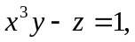 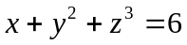 is x=1, y=2, z=1. Use calculus to estimate the corresponding x and y when z=1.1.

2. Given the system of equations 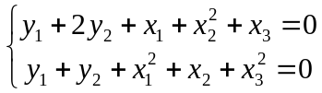, find 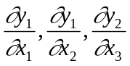.

3. Find du if 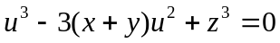.

4. The economy of Northern Saskatchewan is in equilibrium when the system of equation 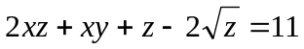, 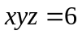 is satisfied. One solution of this set of equations is x=3, y=2, z=1, and Northern Saskatchewan is in equilibrium at this point. Suppose that the prime minister discovers that the variable z (output of beaver pelts) can be controlled by simple decree.
a) If the prime minister raises z to 1.1, use calculus to estimate the change in x and y.
b) If x were in the control of the prime minister and not y or z, explain why you can not use this method to estimate the effect of reducing x from 3 to 2.95.

5. Find 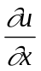 and 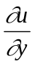 for the function 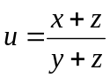, if z is defined by the equation 

